Chapter 2, Problem 70.

- Consider the Wheatstone Bridge shown in Fig. 2.130. Calculate v_{a} , v_{b} , and
- Rework part (a) if the ground is placed at a instead of o.

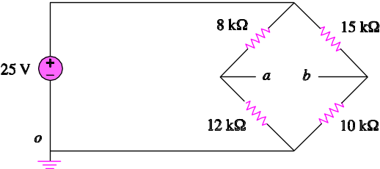

Figure 2.130
For Prob. 2.70.

